**Project Soldering Station**

|  |  |
| --- | --- |
| Author | Felix Kremer |

Content

1 Introduction 1

2 Material and methods 2

3 Results 4

3.1 Schematic & PCB 5

3.1.1 Schematic 5

3.1.2 PCB 6

3.2 Mechanical design & Finalized product 7

3.2.1 Mechanical design 7

3.2.2 Finalized product 7

4 Discussion 8

5 Reference list 8

# Introduction

The project that will be discussed in this application note is a soldering station.  
Its main purpose is to solder components to PCBs (printable circuit board) or to connect cables with good reliability. Some steps are important to get a good connection between the component and the PCB, such as temperature control and an accurate reading of the temperature. The schematic and components originated from a Elector article.   
In this article it also explains what the functions and features are. Furthermore, the used materials, methods, pros and cons shall be discussed.

# Material and methods

The soldering station cannot work without four main parts of the PCB, the power supply, power and temperature management, display and the main IC (Integrated circuit).

The power supply is made using a transistor, this brings the 230V from the outlet to 12V which most of the project uses. There is still one problem, the electricity is still AC and the power needs to be DC. Hence two bridge rectifiers are used. By using two, the voltage can be added up to either 12V or when 1 is used 6V which the IC’s use.

Power and temperature management are used to heat up and measure the temperature of the soldering iron. The power section used transistors to control the MOSFET. A MOSFET can switch on and off extremely fast so the longer it’s on the hotter the iron gets. Temperature is measured by a probe in the iron which signal is amplified by an op-amp.

The display uses a 7-segment display to display the current temperature and desired temperature. Next to the display is a rotary switch with a push button used to set the temperature.

Lastly the main IC controls how long the MOSFET must stay on based on current and the desired temperature. It also calculates the current temp based on the voltage it gets from the amplified probe signal and communicates this to the Display IC. Diagram



To make sure the project goes without many hiccups it’s best to split up the project in multiple steps. By doing this the chances of making mistakes are lower. First step is making a schematic and a bill of materials. Make sure when selecting components that those are available and not on back order, this makes sure the components will be delivered on time.  
Then the next step is to design the PCB, with this it’s important to choose the right size of the PCB. To small makes it difficult to assemble while to big increases the costs. Then when the design is finalized the PCB and components can be ordered. When everything is ordered a case for the project can be designed. Using the dimensions of the PCB makes sure that it’ll fit.  
When the parts arrive the soldering can start. When everything is soldered starts the testing phase can begin. First test if there are any shorts or bad connections when this is al well and good then the board can be powered on. If the CPUs are trough hole it’s better to not install them on the first power cycle so if there’s a short somewhere the CPU isn’t fried.  
Now is a good time to finish the case since when soldering not everything goes to plan and maybe a quick fix is needed. This won’t always work with the case so now is a good time to make sure these changes don’t affect he usability of the case. If the design is finalized, it can be made with a 3D printer or milling machine. Lastly but not least the software can be loaded on the CPU and the last test can be done. Then the PCB can be installed in the case and the project is done.

# Results

## Schematic & PCB

### Schematic

The schematic is split up in 4 parts to make it easier to work with. This also has the benefits that components will be grouped together based on which schematic they’re part of making designing the PCB easier.

First the main board this is the part that contains the CPU the brains of the soldering station. There isn’t much to say about the board, other than the large number of connectors which are there to monitor the CPU and can be used to add other functions in the future.

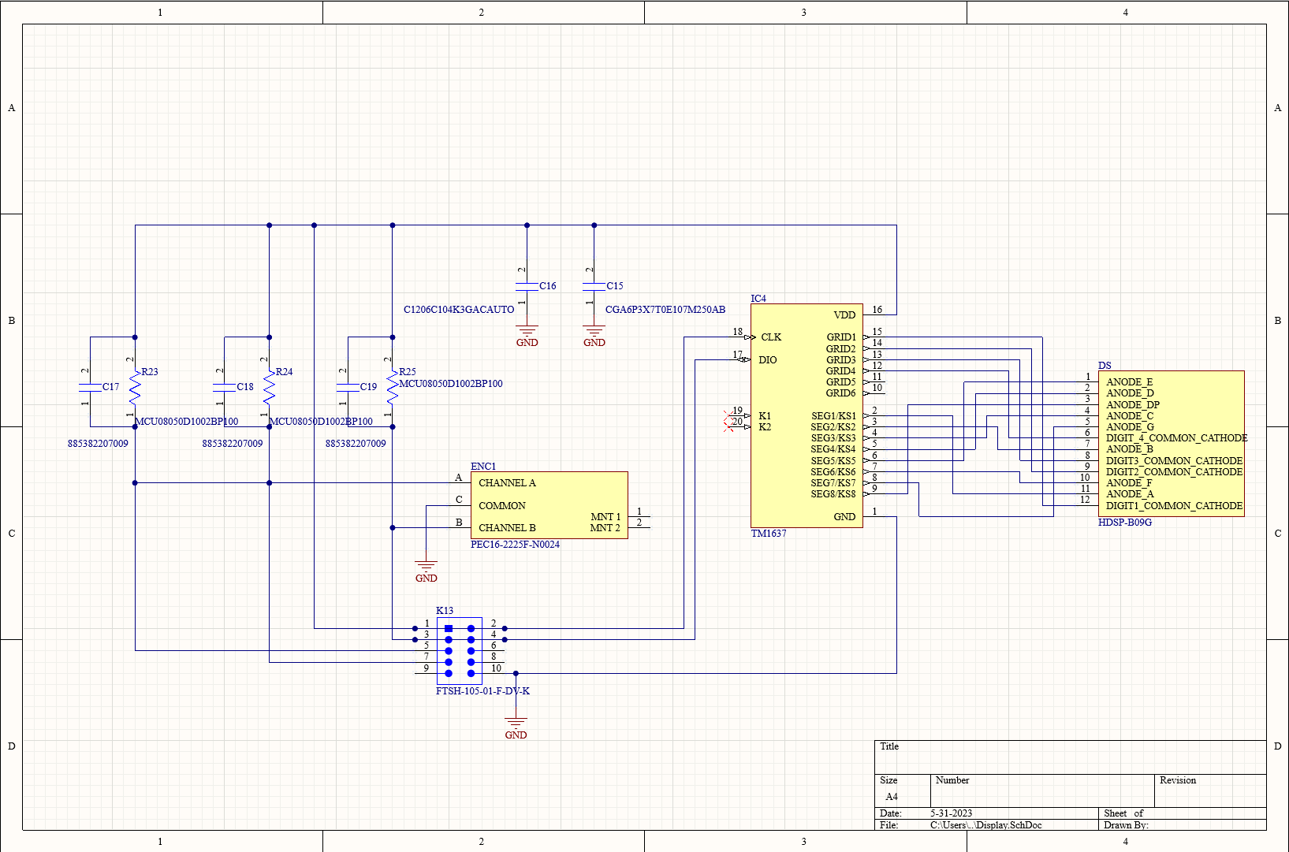

The display board contains the 4-digit 7 segment display and the IC that controls it. This is connected with a flat cable to the main board so that it can be placed further away. This makes the case easier than design and less bulky.

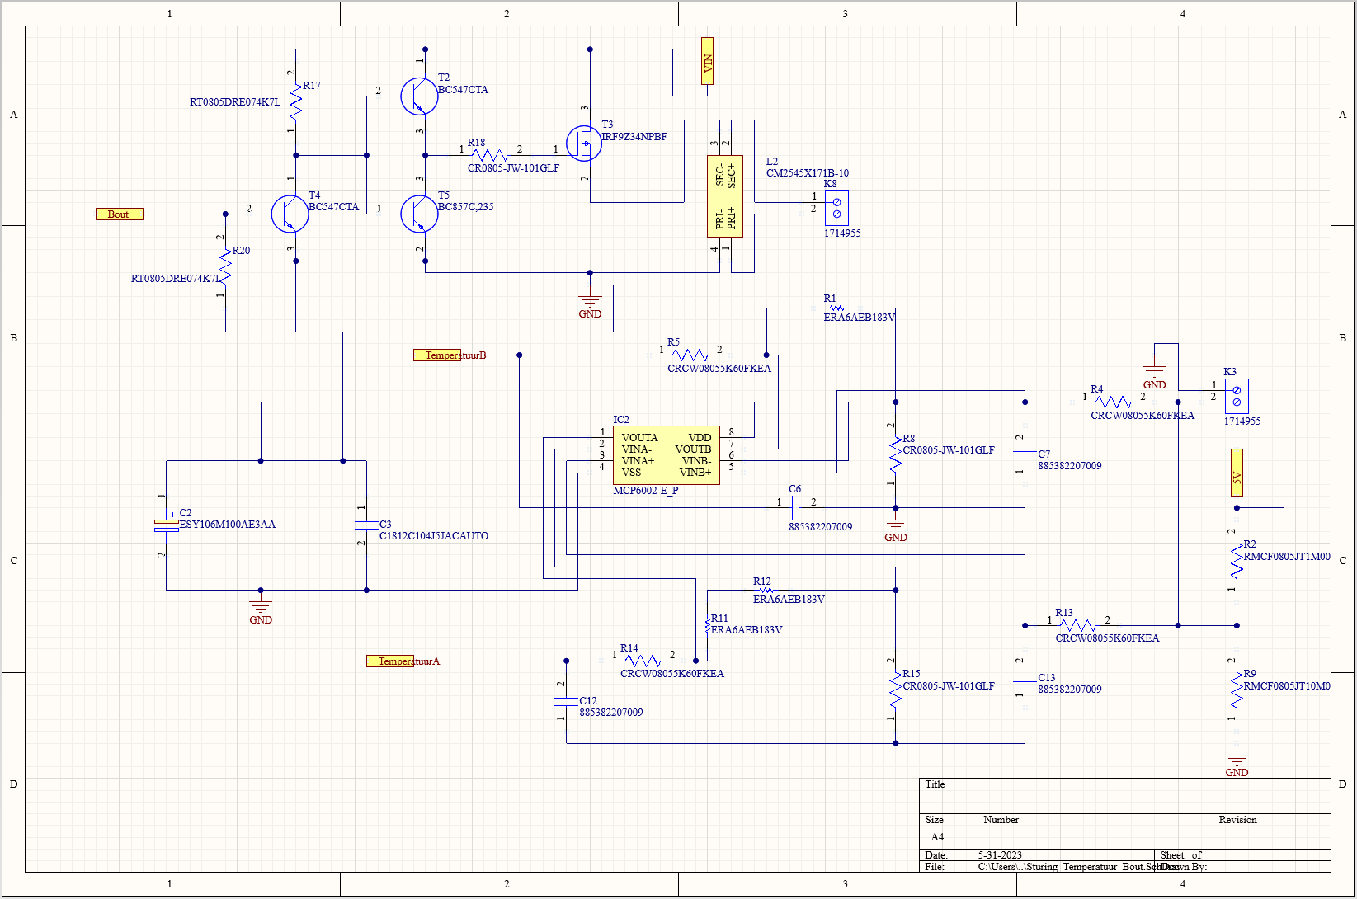

This is the part that’s responsible for giving the soldering iron its power and to amplify the value from the temperature sensor. By switching the MOSFET T3 on and off very fast generates a square wave the duty cycle of this wave determines the temperature the iron will have.   
The sensor outputs a small voltage to connector K3 this is amplified to two different outcomes then the software will take the right one depending on which iron is used.

Lastly the power circuit this is responsible for taking the 2 times 12V from the transformer and transforming it to 5V which the entire circuit uses. The 12V is used to power the soldering iron with the help of the aforementioned MOSFET T3.

### PCB

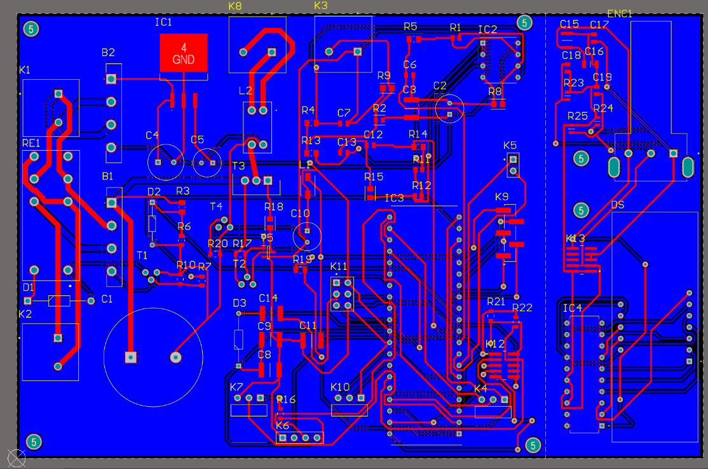

The parts on the PCB have been arranged in a way that all the places that need to be able to support a high current are close. This way the wider tracks don’t need to run all over the board. The display board is connected to the main board but with a break line. Most manufacturers will mill part of the PCB here so it can be easily broken. There are holes placed on the 4 corners of the main board to secure it in place. Meanwhile, the display board has 2 as its smaller and lighter.

## Mechanical design & Finalized product

### Mechanical design

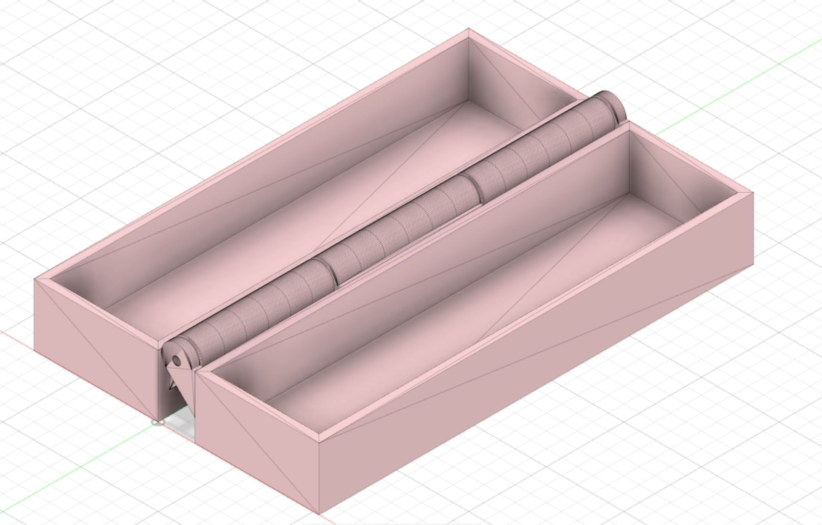

A simple design that doesn’t take up allot of space. It has the screen protected by closing the lid and extra soldering tips and soldering tin can be stored in a shelf that covers up the PCB. It’s made from an old wooden tea box. With a code of paint and some modifications it’s a good case. By making it out of an existing box it has less of an environmental impact since little new resources have to be used.  
It also safes on costs and doesn’t require a 3D printer which most people don’t have.

### Finalized product

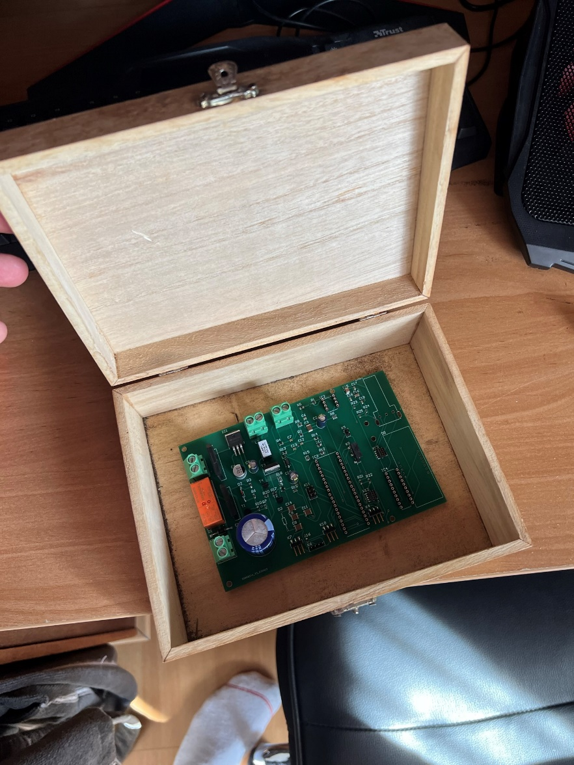

This is the soldering station in all its glory. Not perfect but good enough. The final products is a result of good ideas and some last minute decisions due to time constraints.

# Discussion

There were some difficulties along the way. The biggest being the components that weren’t ordered. The CPU, transformer and the IC that controls the display were things I forgot to order. Some components aren’t the right size or just the wrong one. The display I ordered was too big while the rotary switch was just a variable resistor without the switch. Some resistor values aren’t right this is a fault in the design from elector which this project is based on.  
The CPU was ordered later while forgetting the transformer. The display board couldn’t be saved in time so I had to continue without a working display. With testing I couldn’t use other display boards as my flat cable connector is smaller. Also, we aren’t allowed to use other people’s parts by Mr Hilven, which makes the project a expensive pile of E-waste.

If the project had to be done again, I would probably buy a ready to use display board which makes includes the IC and display, this way it only needs data to work. The switch would also be connected with a wire this way it needs less space than a separate PCB. Also, I would ask which components we actually need to own since Mr Hilven constantly changes opinion on what we actually are allowed to use. I start the production of the case allot sooner so there’s a 3D printer available.   
Some of these issues can be fixed the display board can be remade if the main boards works properly. The wrong resistors have to be resoldered with the right ones which is allot of work and needs another soldering station.  
All parties are responsible for at least one mistake. I didn’t check good enough if everything would fit. Elector had wrong resistor values making the temperature reading not correct. Lastly Mr Hilven changed his mind all the time on what we should have and not comminating this good enough.

# Reference list

[Insert your reference list here.]